**REPORT**

on

**“Anadyanta Event Management Website”**

# 

# NITTE MEENAKSHI INSTITUTE OF TECHNOLOGY

# Submitted in partial fulfilment of the requirement for the award of degree of bachelor of technology in Information science, Bangalore

**BIG DATA LAB**

# Submitted To: Prashanth B S

# DEPARTMENT OF ISE

# NMIT

# Submitted By: 6th sem ‘C’ Section

**C-2 batch**

* Tripti : 1NT17IS182
* Shravani V U : 1NT17IS157
* Shivani Kashyap : 1NT17IS156
* Shreyas S : 1NT17IS161
* Shubhajit Das : 1NT17IS162
* Sneha Kalagi : 1NT17IS165
* Sonali.D.R : 1NT17IS166
* Sumit Kumar : 1NT17IS167
* Swathi A : 1NT17IS173
* Skanda Bhat : 1NT17IS158
* Ujwal Saxena : 1NT17IS183
* V Navneeth : 1NT17IS184
* Vaibhav B V : 1NT17IS185
* Vaibhav Gautam : 1NT17IS186
* Vaibhav Sharma : 1NT17IS187

# ABSTRACT

The event management tool is a process of organizing and managing the students’ achievements in all fields .It provides real-time up-to date information of the achievements .This is done by organizing and categorizing their achievements into technical,sport and cultural events.It checks the validity of the information.

It can lead to error free and a reliable management system. Such a management system reduces the manual efforts taken to organize the data by 80%.Thus,by keeping the information consistent and updated in real-time , time and effort taken in managing the data can be reduced.

**System Requirements**

Front-End language: HTML,css,bootstrap,express js

Back-end/Server-side language: Node.js

Database used : Mongodb

**Project Goal**

Our project is a web-based management application which can be used by NMIT for managing our Fest ANADYANTA.

It Enables the participants to register for various events.

**Project Description**

**1.About us**

It describes the history of our fest and the famous events held in the past.

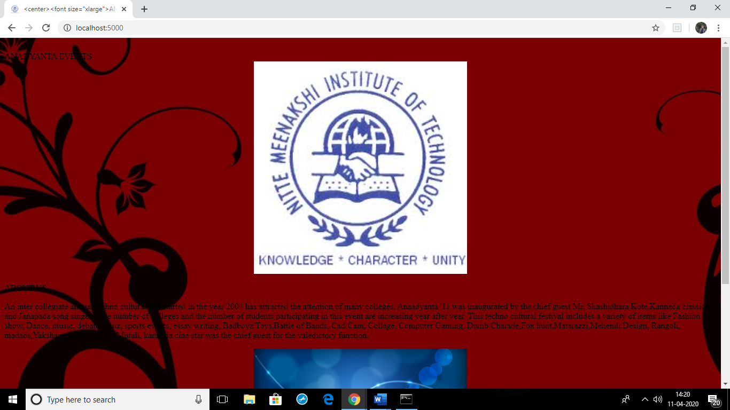

**2.GALLERY**

It gives the pictures and logos and posters of some of the events

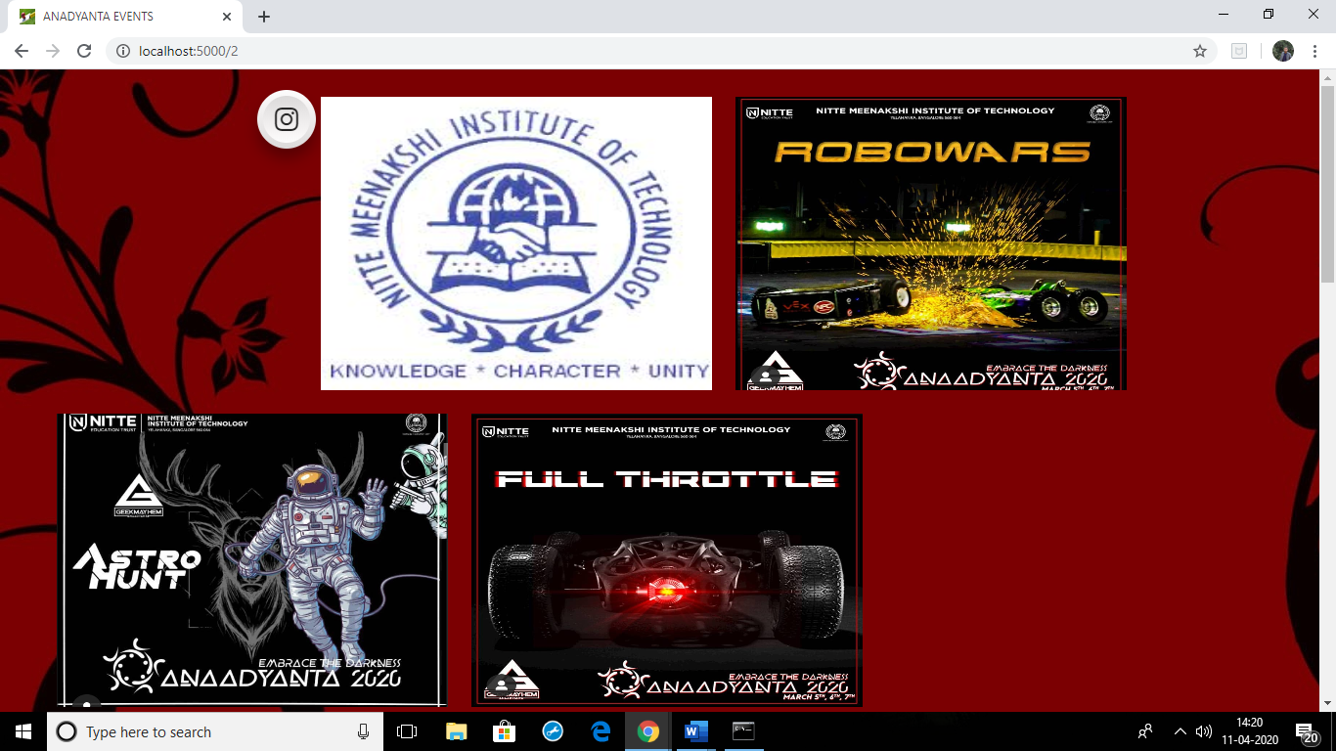

**3.EVENTS**

It gives us a glimpse of events which are about to be held.

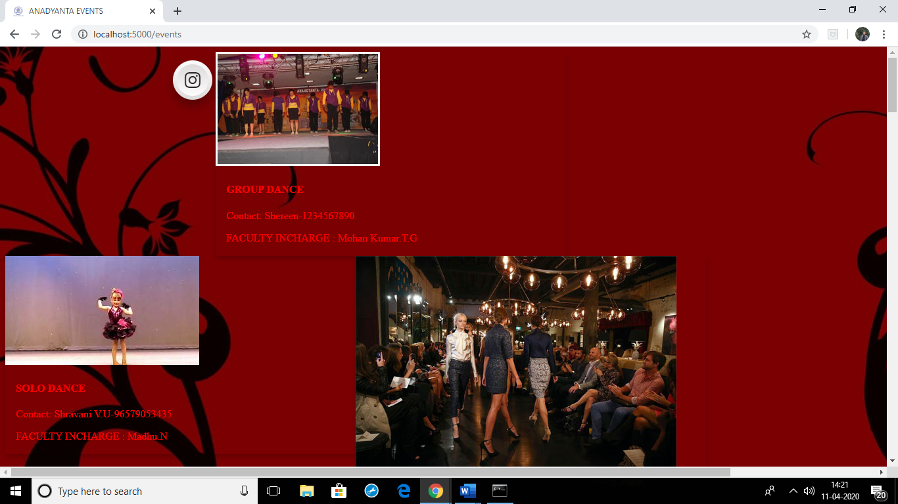

**4.REGISTRATION**

It enables the participants to register for various events by filling in some details.

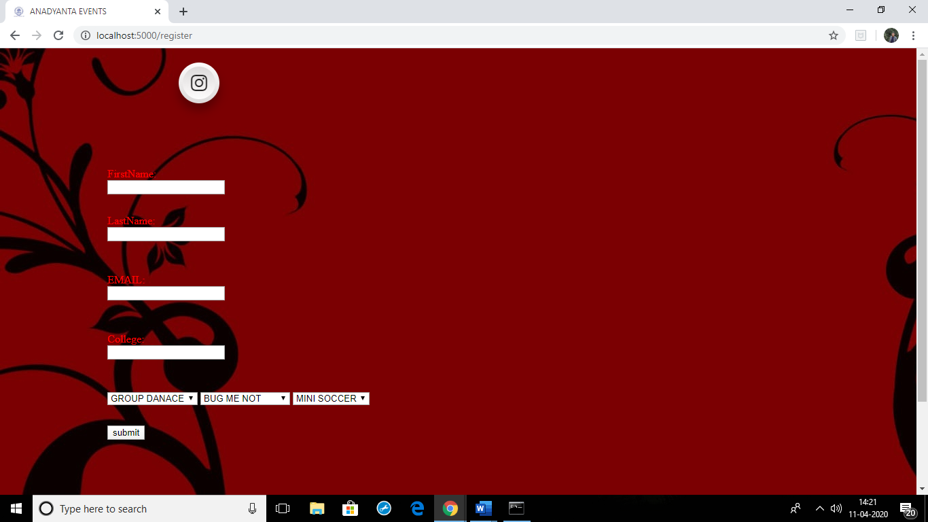

**Conclusion**

Our project can be used to satisfy the needs to manage the records of the student details and their achievements for the respective event. Several user friendly coding have also been adopted. This project satisfies all the requirements needed to organize ,manage and update the data regularly.